In this analysis, you will analyze data from Onset study case-control dataset from Homework 1. As a reminder, these data are from a nested, density-sampled case-control study based upon the first 5 years of follow-up of participants in the Myocardial Infarction Onset Study. In this analysis, you will extend on the evaluation of the relationship between having diabetes at the time of the baseline interview and death from cardiovascular causes within the first 5 years after enrollment.

1. Read the dataset into your preferred software package.
2. Prepare a 2x2 table and compute the odds ratio for the association between diabetes at baseline and case status (death from cardiovascular causes).

1. Write out a logistic regression model with case status as the outcome, and diabetes at baseline as the only independent variable in the model.
   1. What is the interpretation of β1?

1. Fit the model you described in question 3.
2. Fit a model evaluating the association between diabetes at baseline and CVD death adjusting for age as a continuous variable.

1. What is the odds ratio for the association between a 10-year increment in age and CVD death after adjusting for diabetes at baseline?

1. Extend the model you fit in question 5 to evaluate the association between diabetes at baseline after adjusting for age (continuous), hypertension at baseline, sex at birth, physical activity (3 categories), and educational attainment (3 categories). Interpret the odds ratio and 95% confidence interval for the association between diabetes at baseline and CVD death.

1. Extend the model that you fit in question 7 to evaluate whether there is evidence that the association between diabetes and CVD death is different for those with and without a history of hypertension.

Yes.

1. Compute the point estimate and 95% confidence interval for the association between diabetes at baseline and CVD death among participants free of hypertension.

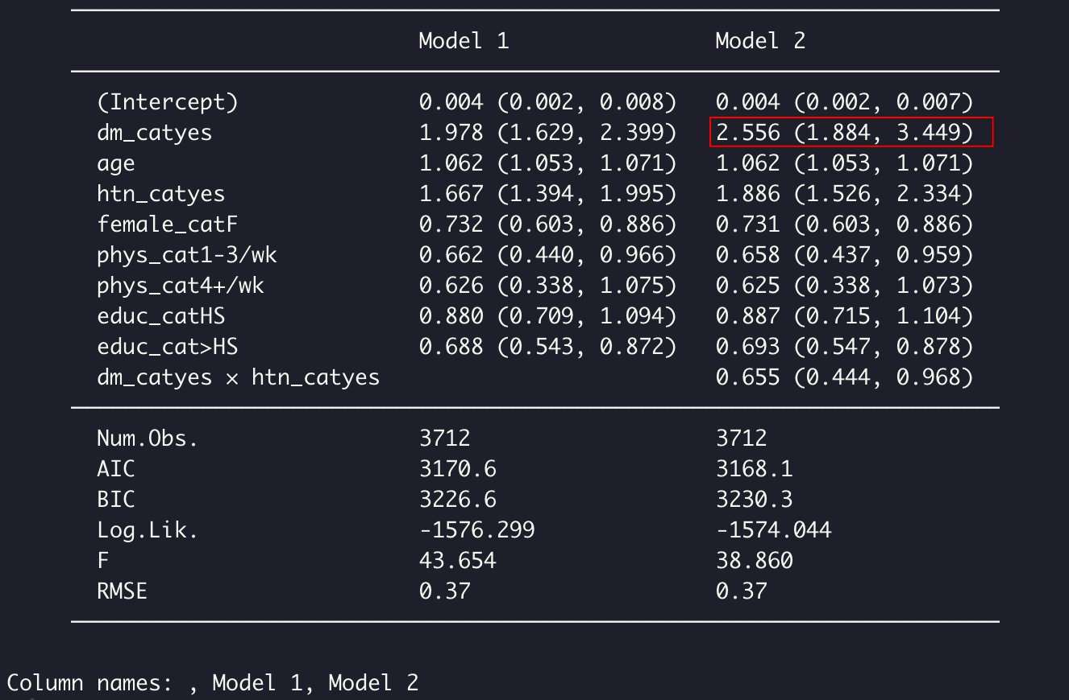

1. Compute the point estimate and 95% confidence interval for the association between diabetes at baseline and CVD death among participants with hypertension at baseline.

0.837, 3.337

